
Version: 1.0
land management system
Software Design Description Document
June 10, 2026
MARYAM SAJID
Session: 2023-2027
S23BINFT1M01068
Department of Information Technology
Revision History
Date | Description | Author | Comments
<date> | <Version 1> | Maryam Sajid | <First Revision>

Document Approval
The following Software Requirements Specification has been accepted and approved by the following:
Signature | Printed Name | Title | Date
 | Mr. Faisal Shahzad | Supervisor, BSIT | <date>

Table of Contents

1. INTRODUCTION 3
2. SYSTEM OVERVIEW 4
3. SYSTEM ARCHITECTURE 5
Data Layer (SQLite) 5
4.E-R Diagram 10
5. DATA DESIGN 10
6. COMPONENT DESIGN 13
7. HUMAN INTERFACE DESIGN 14
8. REQUIREMENTS MATRIX 16
9. APPENDICES 17

1. INTRODUCTION
1.1 Purpose
This Software Design Document (SDD) provides a detailed architectural and design description of the Smart Property Portal, a web-based real estate listing platform.
It is intended for developers, testers, project supervisors, and stakeholders involved in understanding the technical structure, design decisions, and system components required to build the platform.
1.2 Scope
The Smart Property Portal allows Sellers and Agents to securely authenticate, create property listings, and submit them for moderation, while Buyers can search approved listings using filters such as city, area, type, and price. The system includes a listing creation and approval workflow, a search and filter engine, detailed property pages, and an admin dashboard for CMS and overall platform management. The SDD describes the technical design and implementation of these features in a structured and detailed manner.
1.3 Overview
This document describes architecture, database design, modules decomposition, UI design, component design, and mapping of SRS requirements to system components.
1.4 Reference Material
The Software Requirements Specification (SRS) for the Smart Property Portal is supported by technical references including Django and React documentation, SQLite documentation, and established REST API standards, which together guide the system’s architecture, development, and integration practices.
1.5 Definitions and Acronyms
A Buyer is a user searching for properties, while a Seller or Agent is a user posting listings, and the Admin acts as the system controller or moderator. A Listing refers to a property advertised for sale or rent, the CMS is the Content Management System used for managing platform content, the API is the Application Programming Interface enabling communication between system components, and CRUD represents the core operations: Create, Read, Update, and Delete.

2. SYSTEM OVERVIEW
The Smart Property Portal is a web system built using:
Backend: Django (session-based authentication, REST APIs)
Frontend: React.js
Database: SQLite
Media Storage: Django Media for images
Key modules:
- Authentication
- Listing Management
- Search & Filters
- Property Details
- Admin Moderation
- Cities/Areas & CMS Management
The system ensures safe, moderated property sharing and easy browsing for buyers.

3. SYSTEM ARCHITECTURE
3.1 Architectural Design
Presentation Layer (React.js)
- Login/Registration pages
- Property search interface
- Property detail view
- Seller dashboard
- Admin panel UI

Application Layer (Django)
- Handles business logic
- Validates listing inputs
- Performs approvals, rejections
- Communicates through REST APIs
Data Layer (SQLite)
- User table
- Property table
- City/Area tables
- CMS pages
- Images table
High-Level Modules:
- User Module – manages authentication & roles
- Property Listing Module – add/edit/delete listings
- Search & Filter Module – returns approved listings
- Admin Module – approvals, user management, CMS
- Media Module – stores images

Architecture Diagram (Text Form)
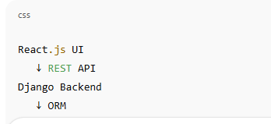

Architecture Diagram
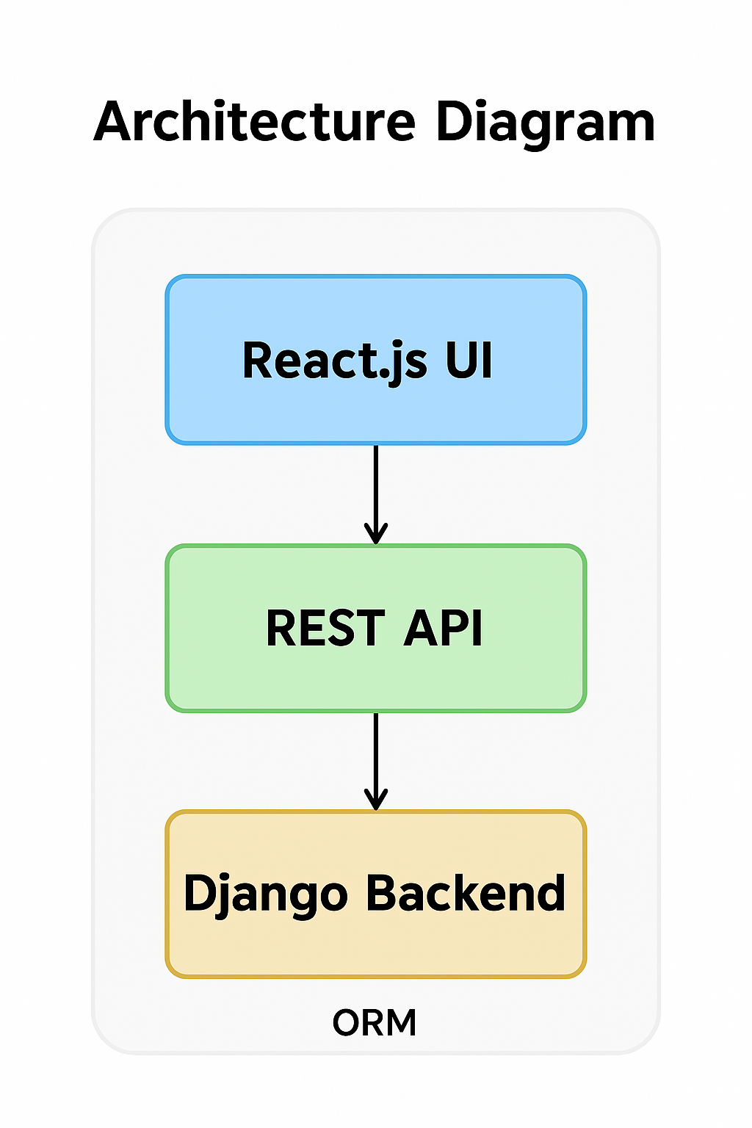

Figure 3.1: Architecture Diagram

3.2 Decomposition Description
Subsystem 1: Authentication
- Register user
- Login/Logout
- Session management
Subsystem 2: Listings Management
- Add listing
- Validate fields
- Upload multiple images
- Edit/delete listing
Subsystem 3: Search Engine
- Filter by city/area/type/purpose
- Sorting options
- Display approved listings
Subsystem 4: Admin Moderation
- Approve/Reject listings
- Manage cities/areas/categories
- Manage CMS pages
Subsystem 5: Property Details
- Full property view with gallery
- Map embedded
- Seller contact info

Data flow diagram
The system consists of six major subsystems that interact to manage real-estate listings, user authentication, media processing, admin moderation, and search functionality. Each subsystem exchanges data with others to complete specific tasks. Below is the flow: 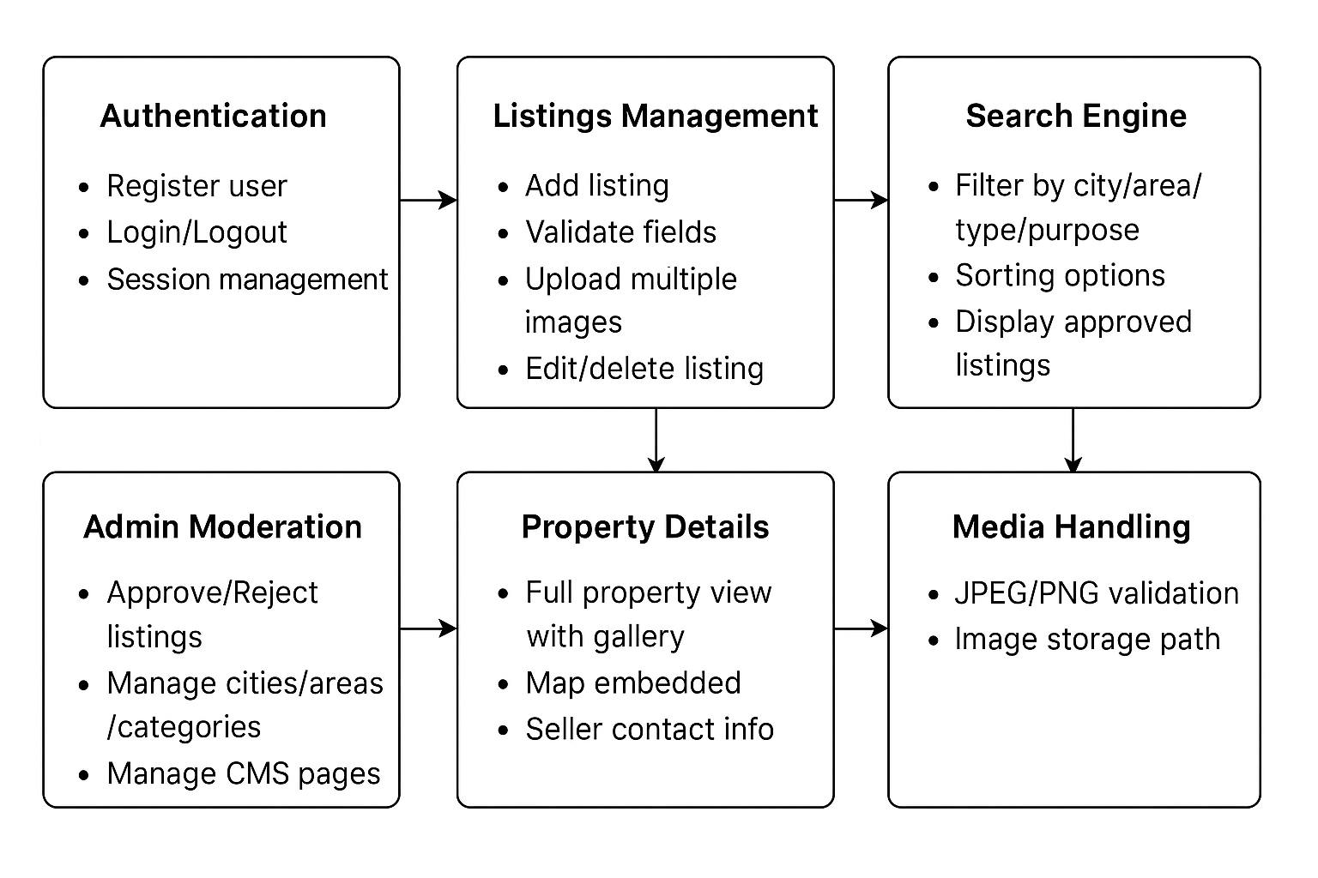

Figure 3.2: Data Flow Diagram of Subsystems
Sequence Diagram
The sequence diagram shows how a user interacts with the real-estate system.
First, the user sends a login request, which is verified by the Authentication subsystem. After successful login, the user requests property listings. The Listings Management subsystem forwards the request to the Search Engine, which returns the filtered listings. When the user selects a specific property, the Search Engine requests full details from the Property Details subsystem, which sends back the complete information including images and seller contact.
Finally, the user can send a logout request, which ends the session.
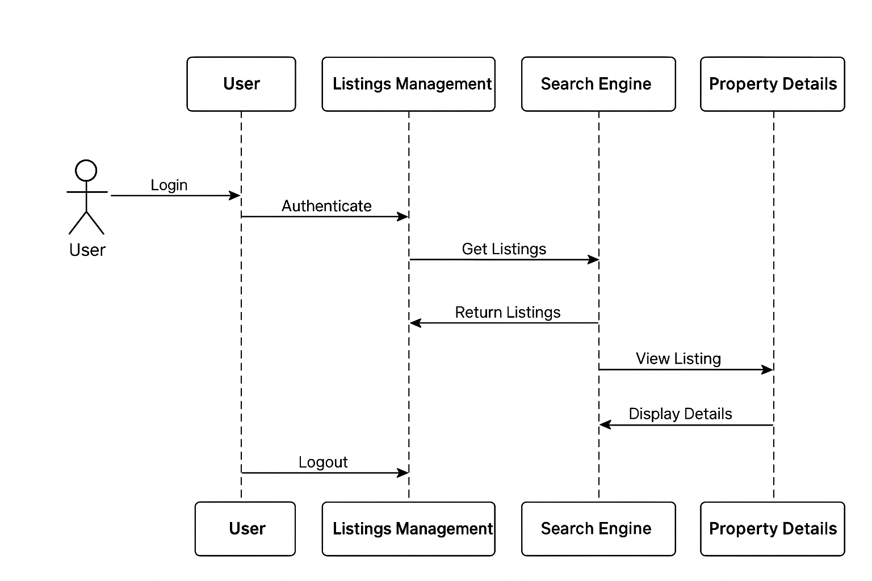

Figure 3.3: Sequence Diagram of User Interaction
3.3 Design Rationale
Django was chosen as the backend framework because it supports fast development, provides strong built-in authentication, offers easy session handling, and includes a reliable ORM that works efficiently with SQLite. React.js was selected for the frontend due to its component-based architecture, fast rendering performance, and ability to create clean, responsive user interfaces. SQLite was chosen as the database because it is lightweight, easy to deploy, and fits well within the scope and requirements of an academic project. Together, these technologies create a streamlined, efficient development stack, while the inclusion of an admin-approval workflow ensures that only verified and approved property listings are visible to buyers, maintaining the platform’s trustworthiness and quality.

4.E-R Diagram
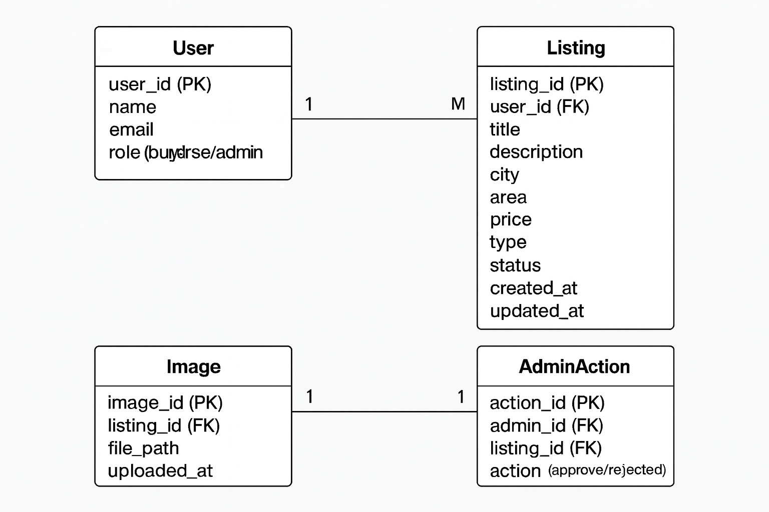

Figure 4.1: Entity-Relationship (E-R) Diagram

5. DATA DESIGN
5.1 Data Description
All system information is stored in structured, normalized tables using SQLite to ensure data consistency, reduced redundancy, and efficient querying. Core entities include Users, Listings, Images, and Admin moderation records, each organized with clear primary and foreign key relationships. The Users table stores authentication details such as username, password hash, email, and role (Buyer, Seller/Agent, Admin). The Listings table maintains property information—title, description, location (city, area), price, property type, status (pending, approved, rejected), and timestamps. Related property images are stored separately using Django’s media file pipeline, where only file paths are saved in the database while the actual images are stored in a dedicated media directory. Additional metadata like search filters, categories, audit logs, and system configuration are also stored in database tables.
The system uses Django’s ORM to manage all data interactions, ensuring type safety, automatic migrations, and secure query handling. Relationships such as one-to-many (e.g., a Listing can have multiple Images) and many-to-one (e.g., Listings belong to one User) are implemented through Django model foreign keys. This structured approach supports efficient search filtering, reliable authentication, secure access control, and robust data management throughout the Smart Property Portal.

5.2 Data Dictionary
The User table stores all user-related information required for authentication, authorization, and communication within the system. It keeps track of personal details, login credentials, and role-based access control for different types of users such as buyers, sellers, and admins. The table also maintains the status of each account to manage access restrictions like banning or disabling users.

User Table
Field | Type | Description
id | int | Primary key
name | text | User full name
email | text | Unique email
phone | text | Contact number
role | text (buyer/seller/admin) | User role
password | text | Hashed password
status | active/banned | Account status
Table 5.1: User Table Data Dictionary
Property Table
The Property table stores detailed information about all real estate listings created by users. It includes essential attributes such as property type, purpose, location, size, and pricing. The table also maintains optional fields like bedrooms and bathrooms, along with a descriptive section for additional details. Each property is assigned a status to support the moderation workflow (pending, approved, or rejected).

Field | Type | Description
id | int | PK
title | text | Property title
type | text | House/Plot/Commercial
purpose | text | Sale/Rent
city | text | City name
area | text | Area name
price | int | Price
size | text | Size of property
bedrooms | int | Optional
bathrooms | int | Optional
description | text | Details
status | text | Pending/Approved/Rejected
Table 5.2: Property Table Data Dictionary

Images Table
The Images table stores all the pictures uploaded for property listings. Each image is linked to a specific property through a foreign key, allowing multiple images to be associated with a single listing. The table also records the storage path of each image so it can be displayed in the property gallery.

Field | Type | Description
id | int | PK
property_id | FK | Linked listing
file_path | text | Image path
Table 5.3: Images Table Data Dictionary

CMS Pages Table
The CMS Pages table stores customizable content pages used throughout the system. It includes a page title and the HTML content for each page, allowing administrators to manage and update informational or static pages without modifying the application's code.

Field | Type | Description
title | text | Page title
content | text | HTML content

Table 5.4: CMS Pages Table Data Dictionary

6. COMPONENT DESIGN

Component 1: Add Property
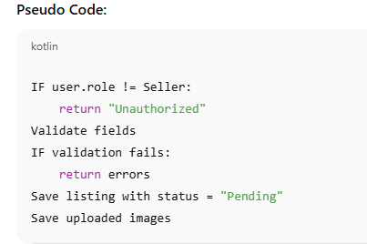
Component 2: Search Engine
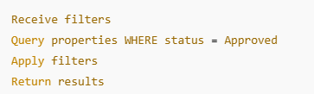

Component 3: Approve/Reject Listing
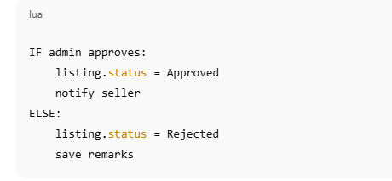

Component 4: Login
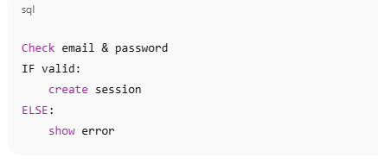

7. HUMAN INTERFACE DESIGN
7.1 Overview of User Interface
The system provides:
- Simple navigation
- Clear menu for Buyers and Sellers
- Dashboard for Sellers
- Admin panel for moderation

7.2 Screen Images
The screen image represents a modern and well-structured real estate portal interface. The layout is clean, with a search panel on the left that allows users to filter properties by city, area, type, and purpose. On the right, the main section displays property cards featuring images, prices, locations, and essential details in a visually appealing grid format. The overall design emphasizes clarity, ease of navigation, and a professional look suited for buyers, sellers, and real estate administrators.

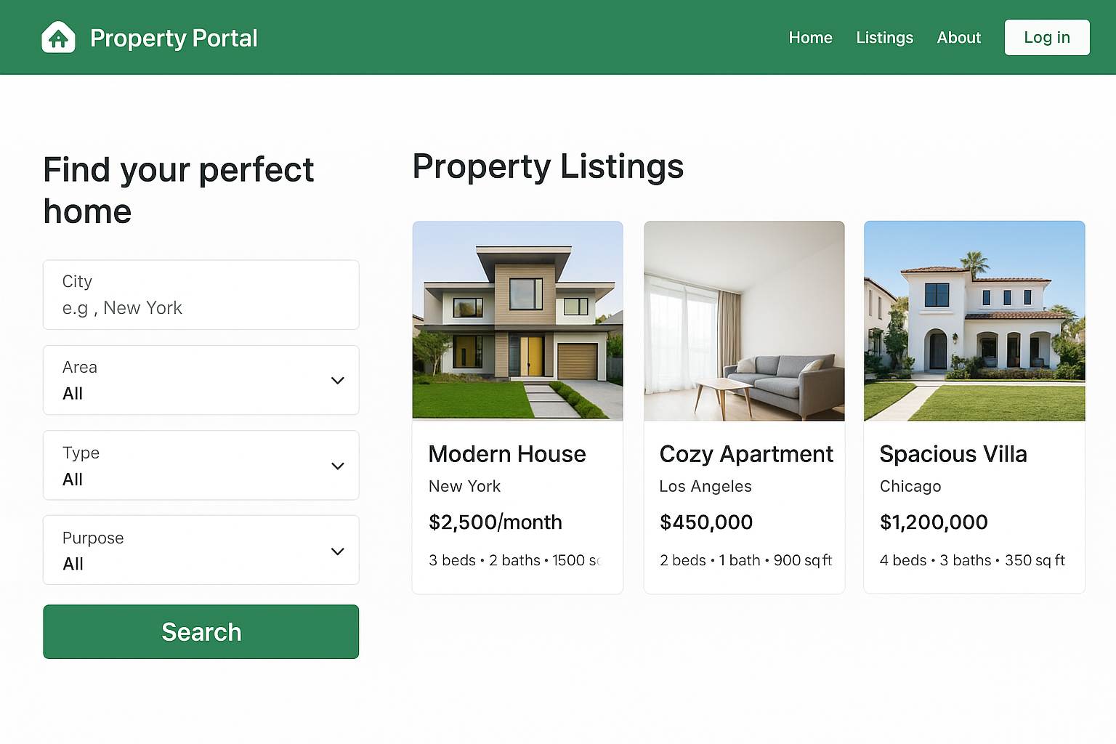

Figure 7.2: Screen Image of Property Portal Interface
7.3 Screen Objects and Actions
The system interface includes several key screen objects that users interact with. The Search Panel provides dropdowns for city, area, type, and purpose, allowing users to filter listings and view results. Property Listing Cards display images, prices, and details, and users can click them to open full property information. The Navigation Bar enables quick access to the home page and login/signup options. On the Property Details Page, users can view the gallery, read descriptions, check the map, and contact the seller. For administrators, the Admin Panel includes tools to approve listings, manage locations, and edit CMS pages. These objects allow smooth navigation and efficient interaction throughout the portal.

8. REQUIREMENTS MATRIX
This cross-reference table links the functional requirements defined in the SRS to their corresponding components and modules in the SDD. Each requirement is mapped to the system element responsible for fulfilling it. For example, the “Add Listing” requirement is supported by Component 1 within the Listings Module, while “Upload Images” is handled through both the data design and the Media Module. Administrative actions such as approving listings are mapped to Component 3 in the Admin Module. Search-related requirements are implemented through Component 2 in the Search Engine, and property viewing is supported by the UI and underlying data design in the Property Details module. Finally, user authentication requirements are addressed by Component 4 in the User Module. This mapping ensures full traceability between requirements and design components.

SRS Requirement | SDD Component | Module
Add Listing | Component 1 | Listings Module
Upload Images | Data Design + Component | Media Module
Approve Listing | Component 3 | Admin Module
Search Properties | Component 2 | Search Engine
View Details | UI + Data Design | Property Details
Authentication | Component 4 | User Module
Table 8.1: Requirements Matrix (SRS Requirement to SDD Component Mapping)

9. APPENDICES
• Extended class diagrams
• Use-case reference
• Additional screen sketches

